

|  |
| --- |
| Nansbook_Prototype1 |
| 22/03/16 12:52 |
| **Author:** John Doe  **File name:** Nansbook_Prototype1.vp  **Version** 1.0 |

|  |
| --- |
| Site Map |
|  |

|  |
| --- |
|  |

01. Site Map / Nansbook_Prototype1 

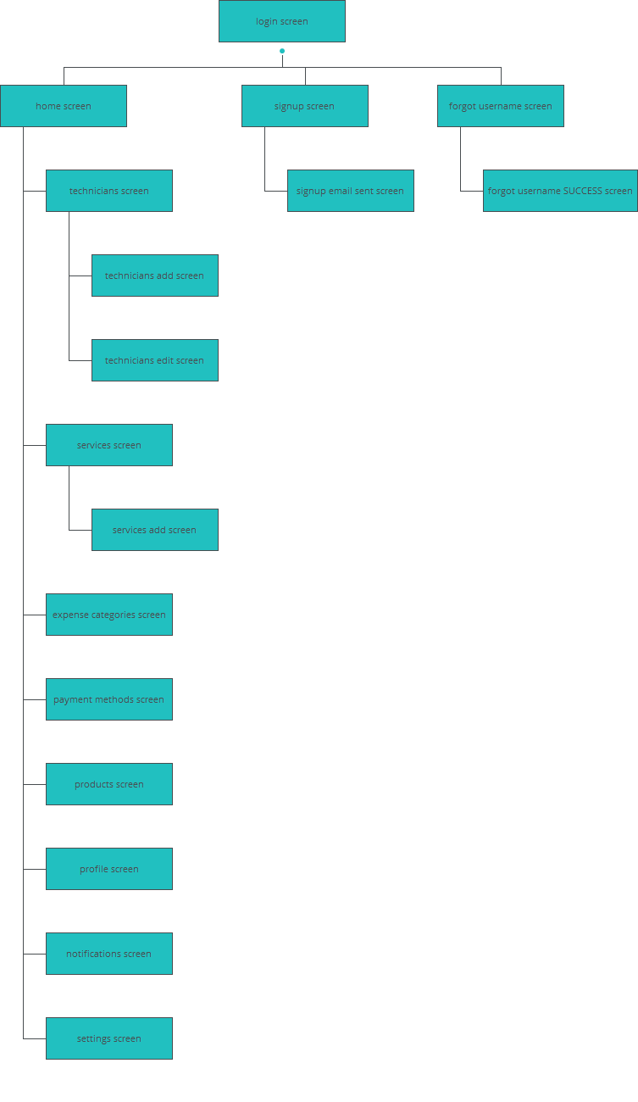

|  |
| --- |
| Screens |
|  |

|  |
| --- |
|  |

02. Screens / Nansbook_Prototype1 

expense categories screen

|  |
| --- |
|  |

Interactions

|  |  |
| --- | --- |
| 6 | **on Click:** goes to 'profile screen' 🡪 |
| 7 | **on Click:** goes to 'notifications screen' 🡪 |
| 8 | **on Click:** goes to 'settings screen' 🡪 |
| 9 | **on Click:** goes to 'home screen' 🡪 |

02. Screens / Nansbook_Prototype1 

forgot username screen

|  |
| --- |
|  |

Interactions

|  |  |
| --- | --- |
| 10 | **on Click:** goes to 'forgot username SUCCESS screen' 🡪 |

02. Screens / Nansbook_Prototype1 

forgot username SUCCESS screen

|  |
| --- |
|  |

Interactions

|  |  |
| --- | --- |
| 11 | **on Click:** goes to 'login screen' 🡪 |

02. Screens / Nansbook_Prototype1 

home screen

|  |
| --- |
|  |

Interactions

|  |  |
| --- | --- |
| 17 | **on Click:** goes to 'profile screen' 🡪 |
| 18 | **on Click:** goes to 'notifications screen' 🡪 |
| 19 | **on Click:** goes to 'settings screen' 🡪 |
| 20 | **on Click:** goes to 'home screen' 🡪 |

02. Screens / Nansbook_Prototype1 

login screen

|  |
| --- |
|  |

Interactions

|  |  |
| --- | --- |
| 21 | **on Click:** goes to 'home screen' 🡪 |
| 22 | **on Click:** goes to 'signup screen' 🡪 |
| 23 | **on Click:** goes to 'forgot username screen' 🡪 |

02. Screens / Nansbook_Prototype1 

notifications screen

|  |
| --- |
|  |

Interactions

|  |  |
| --- | --- |
| 29 | **on Click:** goes to 'profile screen' 🡪 |
| 30 | **on Click:** goes to 'notifications screen' 🡪 |
| 31 | **on Click:** goes to 'settings screen' 🡪 |
| 32 | **on Click:** goes to 'home screen' 🡪 |

02. Screens / Nansbook_Prototype1 

payment methods screen

|  |
| --- |
|  |

Interactions

|  |  |
| --- | --- |
| 38 | **on Click:** goes to 'profile screen' 🡪 |
| 39 | **on Click:** goes to 'notifications screen' 🡪 |
| 40 | **on Click:** goes to 'settings screen' 🡪 |
| 41 | **on Click:** goes to 'home screen' 🡪 |

02. Screens / Nansbook_Prototype1 

products screen

|  |
| --- |
|  |

Interactions

|  |  |
| --- | --- |
| 47 | **on Click:** goes to 'profile screen' 🡪 |
| 48 | **on Click:** goes to 'notifications screen' 🡪 |
| 49 | **on Click:** goes to 'settings screen' 🡪 |
| 50 | **on Click:** goes to 'home screen' 🡪 |

02. Screens / Nansbook_Prototype1 

profile screen

|  |
| --- |
|  |

Interactions

|  |  |
| --- | --- |
| 56 | **on Click:** goes to 'profile screen' 🡪 |
| 57 | **on Click:** goes to 'notifications screen' 🡪 |
| 58 | **on Click:** goes to 'settings screen' 🡪 |
| 59 | **on Click:** goes to 'home screen' 🡪 |

02. Screens / Nansbook_Prototype1 

services add screen

|  |
| --- |
|  |

Interactions

|  |  |
| --- | --- |
| 65 | **on Click:** goes to 'profile screen' 🡪 |
| 66 | **on Click:** goes to 'notifications screen' 🡪 |
| 67 | **on Click:** goes to 'settings screen' 🡪 |
| 68 | **on Click:** goes to 'home screen' 🡪 |
| 69 | **on Click:** goes to 'services screen' 🡪 |

02. Screens / Nansbook_Prototype1 

services screen

|  |
| --- |
|  |

Interactions

|  |  |
| --- | --- |
| 75 | **on Click:** goes to 'services add screen' 🡪 |
| 76 | **on Click:** goes to 'profile screen' 🡪 |
| 77 | **on Click:** goes to 'notifications screen' 🡪 |
| 78 | **on Click:** goes to 'settings screen' 🡪 |
| 79 | **on Click:** goes to 'home screen' 🡪 |

02. Screens / Nansbook_Prototype1 

settings screen

|  |
| --- |
|  |

Interactions

|  |  |
| --- | --- |
| 85 | **on Click:** goes to 'profile screen' 🡪 |
| 86 | **on Click:** goes to 'notifications screen' 🡪 |
| 87 | **on Click:** goes to 'settings screen' 🡪 |
| 88 | **on Click:** goes to 'home screen' 🡪 |

02. Screens / Nansbook_Prototype1 

signup email sent screen

|  |
| --- |
|  |

Interactions

|  |  |
| --- | --- |
| 89 | **on Click:** goes to 'login screen' 🡪 |

02. Screens / Nansbook_Prototype1 

signup screen

|  |
| --- |
|  |

Interactions

|  |  |
| --- | --- |
| 90 | **on Click:** goes to 'signup email sent screen' 🡪 |

02. Screens / Nansbook_Prototype1 

technicians add screen

|  |
| --- |
|  |

Interactions

|  |  |
| --- | --- |
| 96 | **on Click:** goes to 'profile screen' 🡪 |
| 97 | **on Click:** goes to 'notifications screen' 🡪 |
| 98 | **on Click:** goes to 'settings screen' 🡪 |
| 99 | **on Click:** goes to 'home screen' 🡪 |

02. Screens / Nansbook_Prototype1 

technicians edit screen

|  |
| --- |
|  |

Interactions

|  |  |
| --- | --- |
| 105 | **on Click:** goes to 'profile screen' 🡪 |
| 106 | **on Click:** goes to 'notifications screen' 🡪 |
| 107 | **on Click:** goes to 'settings screen' 🡪 |
| 108 | **on Click:** goes to 'home screen' 🡪 |

02. Screens / Nansbook_Prototype1 

technicians screen

|  |
| --- |
|  |

Interactions

|  |  |
| --- | --- |
| 114 | **on Click:** goes to 'technicians add screen' 🡪 |
| 115 | **on Click:** goes to 'technicians edit screen' 🡪 |
| 116 | **on Click:** goes to 'technicians edit screen' 🡪 |
| 117 | **on Click:** goes to 'technicians edit screen' 🡪 |
| 118 | **on Click:** goes to 'technicians edit screen' 🡪 |
| 119 | **on Click:** goes to 'technicians edit screen' 🡪 |
| 120 | **on Click:** goes to 'technicians edit screen' 🡪 |
| 121 | **on Click:** goes to 'profile screen' 🡪 |
| 122 | **on Click:** goes to 'notifications screen' 🡪 |
| 123 | **on Click:** goes to 'settings screen' 🡪 |
| 124 | **on Click:** goes to 'home screen' 🡪 |

|  |
| --- |
| Templates |
|  |

|  |
| --- |
|  |

03. Templates / Nansbook_Prototype1 

Template 1

|  |
| --- |
|  |

|  |
| --- |
| Scenarios |
|  |

|  |
| --- |
|  |

04. Scenarios / Nansbook_Prototype1 

default

|  |
| --- |
|  |

|  |
| --- |
| Data Masters |
|  |

|  |
| --- |
|  |

05. Data Masters / Nansbook_Prototype1 

Mail

|  |  |  |
| --- | --- | --- |
| Attribute name | Type | Values |
| From | text | values |
| Subject | text | values |
| Body | text | values |
| Read | text | values |
| Date | text | values |
| Picture | file upload | values |
| Star | file upload | values |